|  |
| --- |
| O, R & G |
| Personal Inventory Storage Database (PSID) |
| User’s Guide |
|  |
| **O,R&G Staff** |
| **3/30/2017** |

|  |
| --- |
| A User’s Guide and how to use the Personal Storage Inventory Database and its features. |

***Introduction***

*Natural disasters are a part of our world; hurricanes, tornadoes, floods, earthquakes and those who can purchase insurance to cover the costs of having to replace those items that were precious to us. And sometimes it is a matter of trying to regain or replace what was stolen from us in the horrible happen stance of a burglary. Our goal here at O, R & G to help ease the headache that quickly arrives when insurance companies are asking for the value of items or the police needing serial numbers for electronics that have been stolen and with those concerns in mind we created the Personal Storage Inventory Database or PSID for short.*

*We created our program to assist you, our customer, if any of those incidents were to occur in your life. Through the PSID you will be able to input your own ‘inventory’ of your household goods, their value, and weight. Our goal here at O, R & G is keep things easy for the customer and have broken the display up to three sections: Value, Description, and Weight. We chose these terms as they are the most common to universally understand and we’ve found the Weight column has been especially valuable to our military customers or those who often find themselves moving (many moving companies estimate costs based off of weight of the household goods).*

*Our goal is to always create programs, applications, that will make day to day life for anyone easier, less complex, and provide a security blanket during times in need. Again thank you for your purchase of the PSID and if you have any questions or issues with the program we are just a phone call away.*

Sincerely the staff at O, R & G

**Getting Started**

Once the PSID has been run (opened) GUI will be displayed (Figure 1)

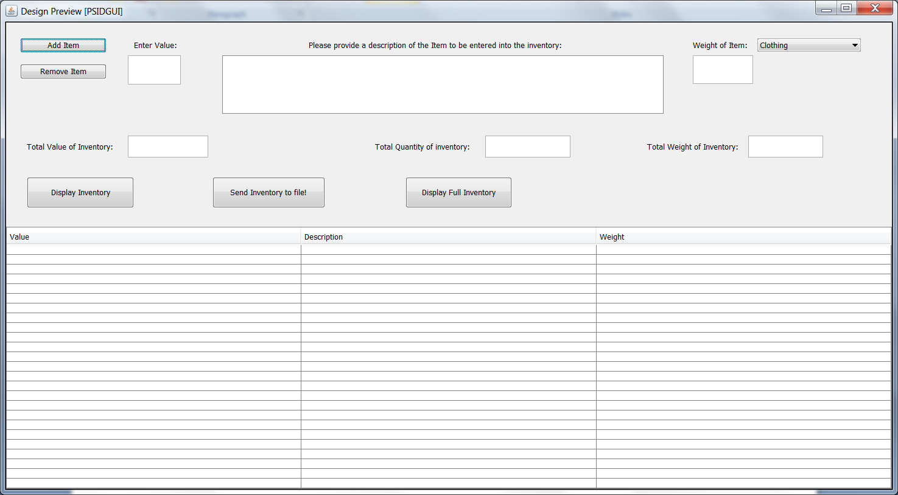

Figure

From the GUI the following buttons are displayed: Add Item, Remove Item, Display Inventory, Send Inventory to file!, and Display Full Inventory.

**Accessing Inventory**

On the top right side of the GUI (Figure 2), is a drop down menu allowing the you to select different inventory databases (Clothing, Electronics, Food, etc).

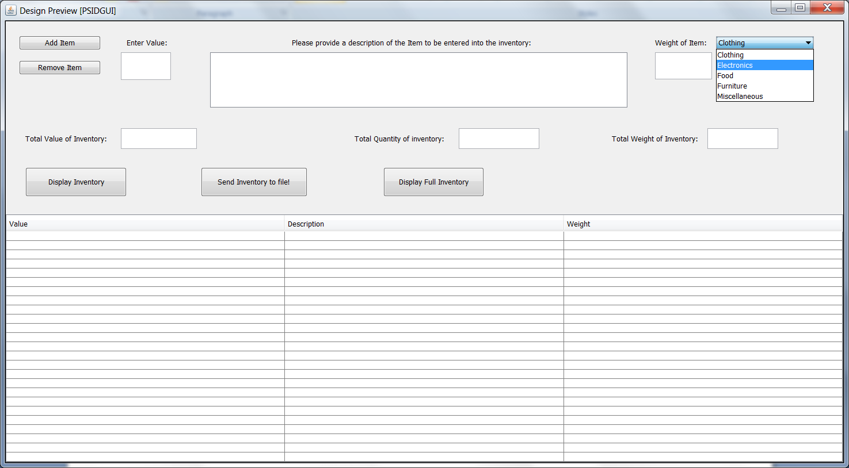

Figure

**Adding an Item**

There are three editable fields (these fields allow you, the user, to input information); they are found at the top of the GUI and are labeled as: ‘Enter Value’, ‘Please provide a description of the item to be entered into the inventory:’, and ‘weight of item:’.

To add an item to the inventory entered a value of the item (if there is no value enter 0), then move to the next text box and type in a description for the item and finally enter the weight of the item (if it is not needed or relevant enter 0); once all fields have been completed ensure the correct inventory (via the drop down menu) is selected and press the “Add Item” button. If the action is successful or there is an error a ‘pop-up’ window will appear to inform you of either result.

**Understanding the Displays**

Below these fields you will see the following labeled areas: ‘Total Value of Inventory’, ‘Total Quantity of Inventory’, and ‘Total Weight of Inventory’. These fields display the respective ‘Totals’ per the inventory selected via the drop down menu.

The bottom half of the GUI display in a table where the inventory that is selected and in conjunction with selecting the ‘Display Inventory’ will contain all the contents of the selected inventory. If the button ‘Display Full Inventory’ is selected the table will transition to display the contents of the entire Personal Storage Inventory Database; when the entire inventory is displayed the ‘Totals’ above the table will change to reflect the entire inventory.

**Sorting the Displayed Inventory**

Through the table by selecting the title of the column (“Value, Description, Weight”) will cause the table layout to sort the contents in ascending order respectively.

**Removing an Item**

By selecting an item on the table and clicking the ‘Remove Item’ button a pop-up window will appear confirming the desire to remove the item from the inventory; if yes is selected the item will be removed from the Personal Storage Inventory Database.

**Creating a Printable Record**

To create a printable record of your inventory you must first ensure you have either selected the appropriate inventory from the drop down menu or pressed the ‘Display Full Inventory’ button. Once either of those has been completed by selecting the ‘Send Inventory to File!’ button a .txt file will be created. The files are created with default names (i.e. clothingInventory, foodInventory, etc) and placed in the same directory the program is stored.